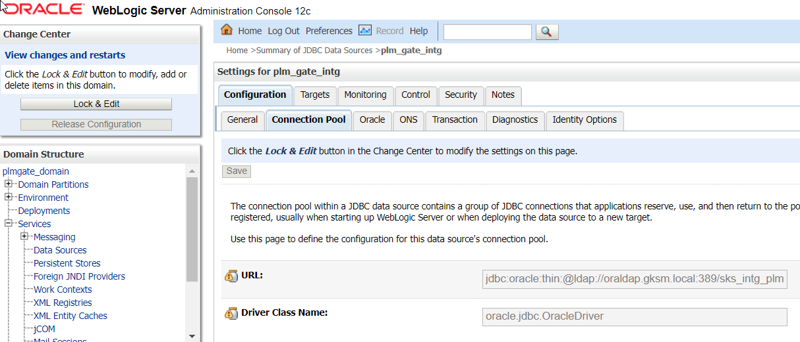

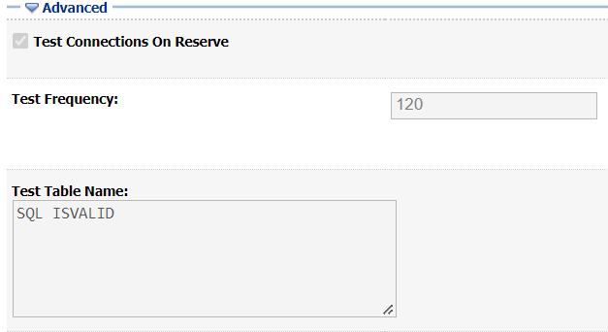



<https://docs.oracle.com/middleware/1213/wls/JDBCA/manage.htm#JDBCA267>

